Buy now before fruit trees wake up
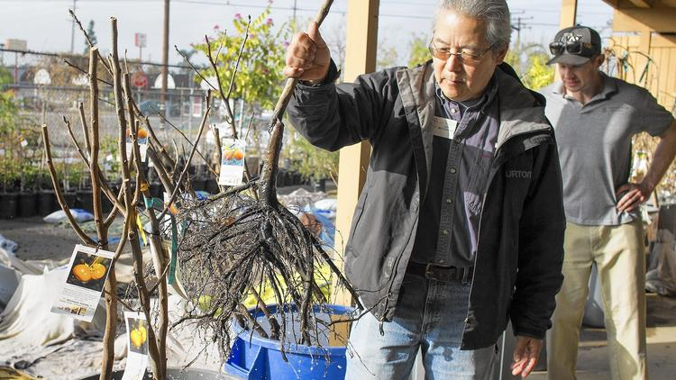
Owner Gary Matsuoka pulls out the bare roots of a fuyu persimmon tree at Laguna Hills Nursery in Santa Ana. The nursery specializes in bare-root fruit plants and roses. (Kevin Chang / Weekend)
Kathleen LuppiContact Reporter
The horticulturist walked between rows of young trees whose bare roots were being kept moist under damp blankets and pulled out a persimmon tree to show a visitor.
"These trees are sleeping," said Gary Matsuoka, owner of Laguna Hills Nursery. "They should stay asleep till March."
Fruit trees, Matsuoka explained, need a long hibernation before they produce the nectarines that are eaten for an outdoor snack and the apples that are sliced for a homemade pie.
However, the window for planting fruit-producing trees in the backyard is nearing its end. Now the plants are still in their dormant stage. But bare roots in particular, Matsuoka said, need to be planted before they begin "waking up."
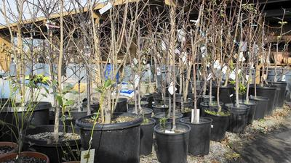
Bare-rooted plants from a year ago, potted at Laguna Hills Nursery in Santa Ana. (Kevin Chang / Weekend)
Laguna Hills Nursery, which has been serving Orange County for 40 years — at its former Lake Forest address and now in Santa Ana — has gained a reputation as the bountiful source of fruit trees, ornamental plants and top potting soil.
While many nurseries have stopped selling bare-root roses and fruit tress, Laguna Hills Nursery continues to offer them because the nursery can hold a large selection and therefore attract more buyers.
Bare-root trees, said Matsuoka and his wife, Nancy, are easier to plant and have a better survival rate than non-bare-root versions.
Bare roots are easier to deal with overall because they weigh less and are easier for the wholesaler to ship. Bare-root plants also yield greater roots because the root ball isn't weighed down by soil. Hence, these plants have a higher rate of survival because their wider root system provides better anchorage once they're established.
They also suffer less transplant shock and produce fruit much faster, the couple say, explaining that bare-root varieties don't come with non-native soil and can better adapt to the environment they become part of.
But care must be taken with the not-yet-planted bare roots. Without soil, the young trees' roots are susceptible to drying out and dying.
The bare-root fruit trees sold to Laguna Hills Nursery were grown in nursery beds in Central California. Once they matured, the young trees were dug up, the soil was removed and they were shipped to the nursery.
To prevent problems, Matsuoka and his staff immediately removed the plants from the packaging and made sure the roots were still moist. They soaked the roots in a bucket of water for several hours and then bagged up the plants individually using wet newspaper. The wrapping process, they said, not only keeps the trees cool but makes it easier for a customer to carry the purchase to a car.
Once the bare-root fruit tree is taken home, it is best to plant it right away. If one cannot plant the tree within a day or two, Matsuoka advised, the roots should be kept wet by wrapping them in the plastic bag and storing the plant in a cool, protected area.
But before picking out a tree, whether bare root or not, Devin Alderton, a certified arborist who works at Laguna Hills Nursery, suggested that shoppers consider the available planting space to make the best selection. One must think about how many hours of sunlight the space gets, for instance.
"You should find a sunny spot that gets sun for five to six hours a day," Alderton said.
Matsuoka said successfully growing fruit trees depends on having some knowledge of the trees and the terrain. Most of the popular commercial apples produce regularly and typically bloom in April, no matter the winter conditions. Apricots are best produced in the flat areas of Orange County, in canyons and along creek beds where cold winter air settles.
But cherries? Don't count on it. Cherries need 700 hours of chilled temperatures.
The new varieties Minnie Royal and Royal Lee are promising but need further local testing.
Laguna Hills Nursery is at 1829 N. Tustin Ave., Santa Ana. For more information, call (714) 542-5600 or visit lagunahillsnursery.com.
Copyright © 2016, Weekend

